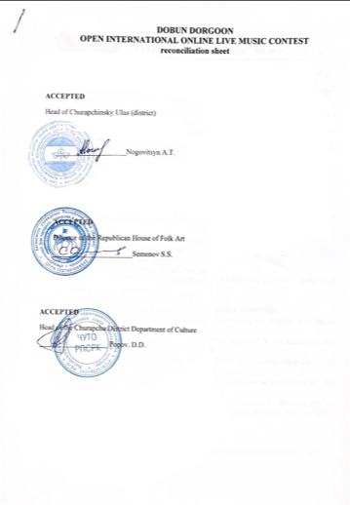

AYLGY Churapcha District House of Folk Art

678670, Republic of Sakha (Yakutia)
Churapchinisky ulus (District),
e-mail: aylgy.churapcha@mail.ru

APPROVED BY
Director of Aylgy Churapcha District House of Folk Art
___________________ Gulyaev P.E.

DOBUN DORGOON
OPEN INTERNATIONAL ONLINE LIVE MUSIC CONTEST
RULES AND REGULATIONS
(Supported by the Republican House of Folk Art,
Head of Churapchinsky Ulus (district),
Churapcha District Department of Culture)

Date of the competition:
The Application process: from April 12 to june 10, 2021
The Results Announcement: June 10, 2021

Project organizers: AYLGY District House of Folk Art, Churapchinisky ulus (District), Republic of Sakha (Yakutia)
Goals and objectives of the contest:
- Promotion live music, vocal and instrumental ensembles;
- Creating conditions for identifying and realizing the creative abilities of young people;
- Implementation of a personality-oriented approach in the formation and development of a creative personality.
- Creation of friendly relations, unification and further cooperation of talented young people from different countries;
- Identification talented groups, creation of favorable conditions for the cultural development of participants;
- Preservation and development of cultural potential, development of crosscultural communication, introduction of talents to the best examples of culture and art.

The Contest Procedure:
- The contest is conducted in absentia, on the Instagram platform @Aylgy.
- The competition is open to all amateur and novice rock bands, vocal and instrumental ensembles from all over the world.
Age categories:
1 age category-students up to and including 17 years of age;
2 age category-adults (no age limit).

The Contest will be held in two nominations:
1. Performances of various genres and styles;
2. Ethno-rock;
- Video recordings of a live performance are allowed for the competition.
- Duplicate main parts, playing with a phonogram (+ plus), video editing, and audio gluing are not allowed;
- the time limit of the contest video is not regulated.
The contest performance is posted by the participants on their Instagram page, the participant marks the page @Aylgy and the hashtag #DOBUNLIVEMUSIC. The contest participant's page must be open.

In order to participate in the Contest the applicants are required to register at the contest website and pay the fee at Instagram platform @Aylgy (the link to the site is located in the header of the Instagram profile of @Aylgy)
- The applicant`s performance is evaluated by the jury. Likes and comments are not taken into account;
- The qualifying round runs from April 12 to June 10, 2021, and the winners are determined on June 10, 2021;

Contest Jury:
The jury of the competition consists of experts in the field of culture and art: recognized figures of culture and art, famous actors, composers, musicians from different republics and countries. The evaluation points according to the competition protocols are not submitted for public discussion. The decision of the jury is final and cannot be changed.

The winners of the competition are determined by the following criteria:
- level of performing skill, expressiveness, quality, culture and technique of performance;
- musicality, artistry of the participants;
- the ensemble structure, the integrity of the performance, the wholeness of the performance.
- performing art, general impression

Prizes and Awards:
- The winner of the competition (GRAND PRIX) is awarded a cash prize of $ 1000 without VAT;
- Laureates and diploma holders are awarded with diplomas and special prizes from the organizers and sponsors of the contest;
- Each participant is awarded a certificate of participation.
(Diplomas and certificates of participation will be send to the participant's email address).

Entry fee:
- 500 rubles per a group member;
Fee payment is made through the contest website, following the link to the site located in the header of the @Aylgy profile(funds from the contributions will go to organizational expenses).
Applications of contestants are accepted on the contest website, the link is located in the header of the @Aylgy profile no later than june 10, 2021, until 00:00 Yakut time. (application form attached);
Please, contact 89248985901 (WhatsApp, telegram), nsesay81@mail.ru
The contest is held on Instagram @Aylgy.

Sample application Appendix No. 1

To the Organizing Committee of DOBUN DORGOON
Open International online live music contest
From (full name):_______________________
_______________________________
Participant's Supervisor:__________

Application form

I`d like to request your permission to participate in DOBUN DORGOON Open International online live music contest.
I hereby acknowledge that I give my consent for the Organizing committee to receive, process, clarify, use, store, destroy my personal data, namely, full name, date of birth, contact details, without the right to transfer to third parties. I have briefed about the regulations and rules of the competition.

Date of filling in_______________________

Applicant's signature_____________________
(full name)

Manager's signature _________________________
(full name)

Appendix No. 2
Filled in by the contestant

To the Organizing Committee of DOBUN DORGOON
Open International online live music contest
From (full name):_______________________
_______________________________
Participant's Supervisor:__________
_______________________________

APPLICATION FORM

I hereby request you to accept a voluntary contribution in the amount of _____________________ rubles for participation in DOBUN DORGOON Open International Online Live Music Contest, which will be held from April 12 to June 10, 2021.

Date _______________________

Applicant's signature_____________________
(Full name)

Sample questionnaire Appendix No. 3

QUESTIONNAIRE
(DOBUN DORGOON Open International Online Live Music Contest)

1. Name of the group (ensemble):_________________________
2. Head of the group (ensemble):________________________________________
3. Age group: ____________________________________________
4. The nomination of the performance:________________________________
5. Name of the contest performance: __________________________________
6. Country (city, district):__________________________________________
7. Institution: __________________________________________________
8. Head of the institution:_____________________________________
9. Contact number: ____________________________________________
10. E-mail:___________________

